Template for Extended Abstracts for the HYDRONAV 2023 Conference

TITLE OF EXTENDED ABSTRACT

First A. Author¹, Second B. Author² and Third C. Author³

^{1, 2} Authors’ Department, Institute, COUNTRY.
(E-mail: firstauthorsname@aaaa.bbb, secondauthorsname@aaaa.bbb)
³ Author’s Department, Institute, COUNTRY.
(E-mail: thirdauthorsname@aaaa.bbb)

Keywords: Hydrodynamics, wave modelling, (up to 6 words, in alphabetical order)

ABSTRACT
The Hydronav2023 e-book will include accepted extended abstracts. The language of abstracts should be English. The extended abstract should be written using Microsoft Word. It should start with the paper’s title, authors, authors’ affiliation, address and e-mail, followed by the Abstract's text and the keywords (up to six). Please indicate the author making the presentation with an asterisk. A digital version of the HYDRONAV 2023 e-book [1] will be published in the conference website.

INTRODUCTION
The abstract should be written in MS Word format in line spacing at least 13 points, font Cambria in 11 points, min 2 pages in the length (preferred 6 pages). Do not indent the text paragraphs. Please, briefly explain the aim and scope of your study, your materials and methods, and the main conclusions of the study. Max 2 figures/photographs can be placed in the abstract.

Format
The structure of the extended abstract should include:
ABSTRACT
1 INTRODUCTION
2 METHODOLOGY
3 RESULTS AND DISCUSSION
4 CONCLUSIONS
ACKNOWLEDGEMENT (OPTIONAL)
REFERENCES
Table 1
Example table for the extended abstract.
Column heading | Column heading two | Column heading three
Row 1a | Row 1b | Row 1c
Row 2a | Row 2b | Row 2c
Row 3a | Row 3b | Row 3c
Row 4a | Row 4b | Row 4c
Row 5a | Row 5b | Row 5c
Row 6a | Row 6b | Row 6c

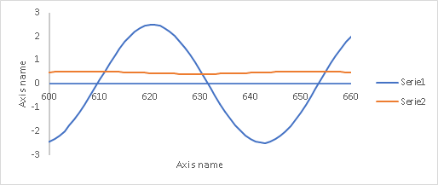
Figure 1 Example graph for the extended abstract.

SUBMISSION
Please send your extended abstract to e-mail address: Hydronav2023@prs.pl in electronic form (MS-Word). The incorrect formats may result in your abstract being returned to you by e-mail.
ACKNOWLEDGMENT
The authors may express appreciation for the support.
REFERENCES
[1] Surname1, N.., Surname2, M., The title of the paper, Magazine, Vol. 25, No. 1, 2021, pp. 32–37.
[2] Surname3, O., Surname4, P., The title of the paper, Name of conference, Warsaw, Poland, 2007, pp. 52–62.
[3] Surname5, R., Surname6, S., The title of the paper, Magazine, Vol. 122, No. , 2021.
[4] Surname7, T., Surname8, U., Name of the book, Name of the publisher, Stockholm, 2001.

